

Rezoon Rasheed
Netflix’s Premium Subscription Pricing Strategy

Babson Olin FW Graduate School of Business
MKT9501-01
STRATEGY & TACTICS OF PRICING
Fall 2025

Professor Dr. Lidija Polutnik

Table of Contents
Introduction 3
Pricing Strategy and Method 3
Customer Analysis 5
Willingness to Pay 5
Price Sensitivity 5
Value Proposition 5
Competition and Market Dynamics 6
Cost Structure Analysis 7
Mission/Strategy 8
Recommendations 9
References 9
Acknowledgement of Generative AI Use 10

Introduction
Netflix is one of the major players in subscription video-on-demand (SVOD) industry, with a global operation of 190 countries and more than 260 million paying customers. Its tiered pricing structure separates users according on their viewing quality preferences and willingness to pay. The Premium tier, which enables 4K Ultra HD streaming, HDR capabilities, spatial audio, up to four concurrent streams, mobile downloads, and the option to join more members for an extra monthly cost, is at the top of this hierarchy. Following more extensive changes to all its membership options, Netflix raised the cost of its Premium plan in the US from $22.99 to $24.99 in January 2025 (Nerdist, 2025). This price revision sits alongside Netflix’s Standard plan at $17.99 and Standard with ads at $7.99, highlighting the company’s intentional vertical product differentiation strategy (Netflix Help Center, 2025).
The streaming market has become more competitive with service provides like Disney+, Max, Hulu, Apple TV+, and Amazon Prime Video offering comparable high-end entertainment alternatives, often at lower price points. For instance, Disney+ Premium costs $18.99, whereas Max Ultimate Ad-Free is $19.99 (Business Insider, 2024). Netflix's Premium strategy makes a compelling case in this regard for examining pricing structure, perceived uniqueness, customer value, and competitive sustainability.

Pricing Strategy and Method
Netflix employs a value-based pricing strategy supported by second degree price discrimination. Rather than tying subscription fees to cost structures, Netflix aligns pricing with perceived value, user benefits, and willingness to pay. The Premium tier offers meaningful experiential upgrades which include, 4K HDR clarity, spatial audio, and multiple simultaneous streams, that distinguish it from the Standard tier and justify a higher price point.
Netflix makes price decisions based on data, regularly evaluating subscriber sensitivity before adjusting. Prior to the 2025 Premium price increase, Netflix monitored user reactions and churn rates during prior global rollouts (e.g., 2023) to modify prices without running the risk of churn (Netflix, 2024). The consistent growth pattern demonstrates that Netflix’s take on value extraction and revenue optimization is working.
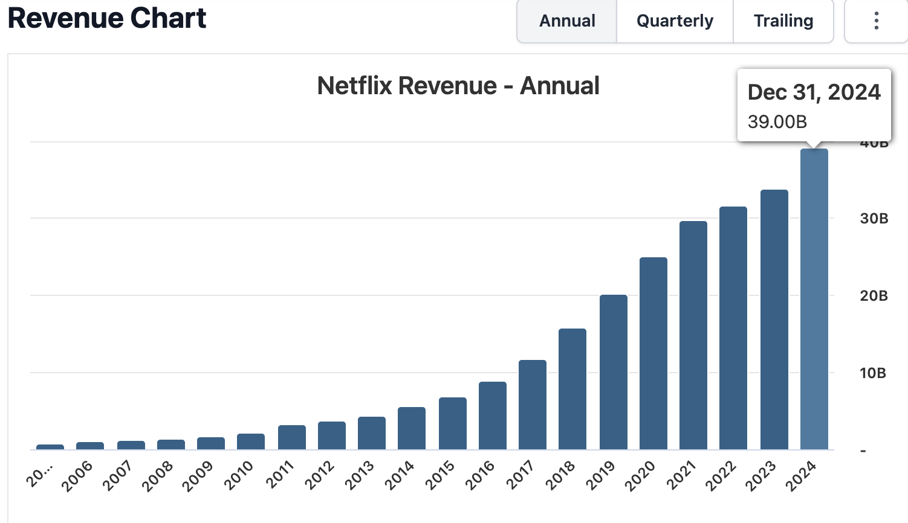

Source: https://stockanalysis.com/stocks/nflx/revenue/
Netflix also enables Premium subscribers to add “extra members” at $7.99 per person. This approach monetizes shared account usage, transforming previously non-paying users into incremental revenue sources while maintaining consumer flexibility.
This price gap shows how Netflix uses versioning to segment high-value users who prioritize elevated audiovisual experiences.

Customer Analysis
Households, entertainment enthusiasts, and viewers that value high-resolution material and smooth multi-device access are the target market for the Premium tier. Features like HDR, 4K clarity, and spatial audio improve the viewing experience, and four continuous streams allow for shared household use. The strong reputation for original screenings like Stranger Things, The Witcher, and Squid Games enhances perceived value for Premium customers.

Willingness to Pay
Netflix’s depicted a subscriber growth during pricing adjustments, which indicates strong willingness to pay. In the 2023 password-sharing enforcement, 9.33 million new subscribers were added, bringing membership to approximately 301.6 million (DemandSage, 2025). This occurred during a period when pricing for multiple tiers increased, suggesting that customers valued content quality, platform convenience, and broader user experience highly enough to accept periodic price hikes, indicating that the customers are less price sensitive.

Price Sensitivity
Compared to other user demographics, premium members typically show less price sensitivity. This is demonstrated by high retention rates following price increases and the availability of downgrade choices, such as moving to Standard or ad-supported tiers, which reduce churn risk. Because they often find value in family sharing, home theater setups, or frequent use, premium customers are less likely to move platforms or stop using a service due to minor price increases.

Value Proposition
Netflix Premium’s value proposition rests on the following differentiating factors:
1. Superior technical quality (4K HDR, spatial audio).
2. High convenience and flexibility (four streams, downloads).
3. Extensive and exclusive content library.
4. Supported account-sharing framework through extra-member add-ons.
These enhance the plan’s attractiveness relative to lower tiers and competitor offerings.

Competition and Market Dynamics
Close competition, growing production budgets, changing content strategies, and multi-tier pricing schemes characterize the premium segment of the streaming market. Because to its extensive original content library, sophisticated recommendation system, and worldwide brand exposure, Netflix Premium maintains a substantial market share despite its higher price.
Premium Tier Pricing Across Competitors (2025)
Service | Monthly Price (USD) | 4K / HDR | Max Simultaneous Streams | Downloads for Offline Viewing
Netflix Premium | $24.99 | Yes – 4K Ultra HD + HDR on supported titles | 4 devices | Yes, on up to 6 devices
Apple TV+ | $12.99 | Yes – 4K HDR / Dolby Vision on supported titles | Up to 6 streams | Yes (Apple TV app)
Paramount+ Premium (with SHOWTIME) | $12.99 | Yes – 4K UHD / Dolby Vision / HDR10 on select titles | Up to 3–4 streams (3 guaranteed across plans) | Yes, offline downloads
Peacock Premium Plus | $16.99 | Yes – 4K on select titles | 3 devices | Yes, offline downloads on select content
Sources: https://help.netflix.com/en/node/24926 , https://www.tvguide.com/news/apple-tv-plus-cost/ , https://www.paramountplus.com/account/signup/pickplan/ , https://www.peacocktv.com/help/article/price-increase
Netflix’s Premium pricing strategy differs by positioning itself at the top of the market while competing on quality and breadth, not price. This is consistent with the company’s longstanding competitive differentiators, that are, large-scale content production, international diversification, and personalization technology, which allow it to maintain higher prices without excessive churn (Nerdist, 2024).
Recent industry development indicates a clear shift toward higher streaming prices, the expansion of ad-supported tiers, and rising content production and licensing costs. Many platforms have also adopted account-sharing restrictions following Netflix’s lead. Together, these changes normalize higher subscription prices across the market, reinforcing the viability of Netflix’s Premium pricing strategy.

Cost Structure Analysis
High fixed costs, especially for platform software development, content creation and licensing, and international marketing campaigns, dominate Netflix's cost structure. Maintaining a strong pipeline of original content and competitive distinctiveness requires these investments (Netflix, 2024).
Network bandwidth for content delivery, customer service, and payment processing are examples of variable expenses that are still comparatively low. Spatial audio optimization and 4K HDR encoding are examples of premium-specific delivery requirements that add little additional costs, but they pale in comparison to the total revenue possibilities.

Netflix Cost Structure Overview
Cost Category | Examples | Cost Behavior
Fixed Costs | Content creation, licensing, technology R&D, marketing | High
Variable Costs | CDN usage, customer service, billing expenses | Low
Sources: https://www.moontechnolabs.com/blog/netflix-business-model/ , https://www.studocu.com/en-us/document/southern-new-hampshire-university/microeconomics/economics-milestone-3/11676123
Because fixed costs dominate, Netflix benefits from substantial economies of scale. With each new subscriber, the company’s ability to amortize content expenditures across a larger audience is increased, thereby supporting higher-margin premium-tier offerings.

Mission/Strategy
Netflix’s mission to “entertain the world” aligns closely with its tiered pricing architecture, which balances global accessibility with incremental revenue extraction from high-value users (Netflix, 2024). The Premium tier plays a central role in this system by driving ARPU growth and supporting long-term investment in content and platform innovation.
Due to their low marginal service cost in relation to pricing, premium clients make a disproportionate contribution to profitability. To maintain perceived value, Netflix must make ongoing enhancements to the user experience, such as adding more 4K content, improving spatial audio support, or providing exclusive access windows, even as it raises costs.

Recommendations
Netflix should connect any future price increases with clear improvements that users can feel whether that means better HDR performance, new viewing formats, or earlier access to major releases. Showing customers what they gain makes price changes easier to accept.
Netflix could also do a work on explaining what Premium already includes. Simple in-app advice or brief lessons could assist customers understand the benefits of the plan, as many people are unaware of what capabilities like spatial audio or HDR do. Additionally, the tier would feel more unique and worthwhile if it included more Premium-only features, such as interactive content, more intelligent tailoring, or improvements for home theater.
Netflix should continue refining its paid-sharing system. Customers are willing to embrace the new model, as seen by the strategy's early success in converting many shared viewers into paying customers. It can continue to be a solid and long-lasting component of Netflix's overall pricing strategy with a few tweaks.

References
- Business Insider. (2024). Netflix price: How much Netflix costs in 2024. https://www.businessinsider.com/guides/streaming/netflix-price
- DemandSage. (2025). Netflix subscribers: How many subscribers does Netflix have? https://www.demandsage.com/netflix-subscribers/
- Nerdist. (2024). Netflix stopping password sharing with price increases. https://nerdist.com/article/netflix-stopping-password-sharing-with-price-increases/
- Nerdist. (2025). Netflix price increases arrive January 2025. https://nerdist.com/article/netflix-price-increases-have-arrived-january-2025-hikes-explained/
- Netflix. (2024). Netflix annual report (Form 10-K). https://s22.q4cdn.com/959853165/files/doc_financials/2024/ar/Netflix-10-K-01272025.pdf
- Netflix Help Center. (2025). Plans and pricing. https://help.netflix.com/en/node/24926

Acknowledgement of Generative AI Use
I acknowledge that to prepare this study, I used ChatGPT to facilitate research and collect publicly accessible data. My personal understanding and original work are reflected in all analysis, arguments, interpretations, and final content. I have used outside sources to confirm all the information.

